# Abstract

This study investigates COVID-19 trends in Victoria and South Australia using exponential and logistic growth models. While exponential fits provide insights at specific points, logistic models, supported by Triambak (2021), better capture growth phases. Initial mitigation slowed the virus but led to surges post-restrictions. Yearly analysis reveals Victoria's decreasing case rate and South Australia's dynamic growth aligned with public health changes, informing healthcare planning.

# Introduction

This project aims to comprehensively analyse the trends of COVID-19 positive test results in Victoria and South Australia, inspired by Cook’s (2020) work on modelling COVID-19 transmission through population groups and Esragh’s (2020) study of transmission control measures reducing the spread of the disease by up to 90% in some Australian states. Further, Chang (2020) highlighted the potential consequences of lifting mitigation measures during the pandemic's peak, warning of the risk of continued exponential growth.

The primary objectives of this project are to:

1. **Examine the applicability of exponential and logistic growth models**
2. **Identify and interpret key parameters**
3. **Assess the impact of public health interventions**
4. **Provide data-driven recommendations**

The motivation for pursuing this project lies in the critical need for accurate and reliable data analysis to inform public health decisions by leveraging advanced modelling techniques.

***Methodology see appendix for the following code to replicate data analysis:***

Data was read from John Hopkins University from 22/1/2020 till 3/10/2023.

[https://data.humdata.org/dataset/novel-coronavirus-2019-ncov-cases.](https://data.humdata.org/dataset/novel-coronavirus-2019-ncov-cases) Using MatLab features and data manipulation, three functions known as getcountries(), getzones() and getinfections() extrapolated the necessary data.

***Figure 1. Corona Confirmed Cases in Australian***

***States***

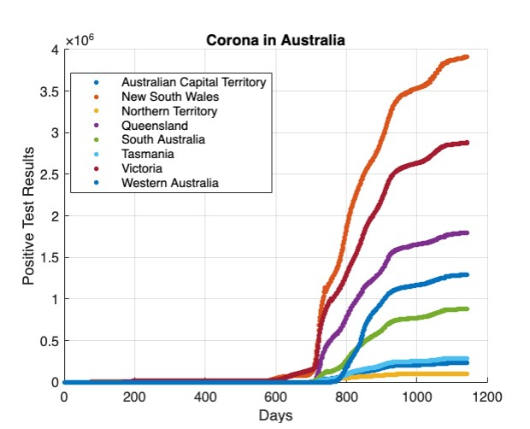

Various models fitting the entire data was used initially. This was further narrowed down to various points in time to determine which models were most appropriate. Trends were plotted employing both exponential and logistic growth models. Models skip the initial days to avoid noise and computes the exponential fit using least squares. Subsequently the logistic model is applied, defining the model function and conducting non-linear least squares fitting. The code further subdivides the data into yearly intervals and fits both models for each year, providing parameter estimates to elucidate COVID19 dynamics and trends.

|  |  |  |
| --- | --- | --- |
| ***Figure 2. Exponential fit using least squares for confirmed cases of COVID-19 in Victoria with parameters*** |  | ***Figure 3. Logistic fit for confirmed cases of***  ***COVID-19 in Victoria with parameters*** |

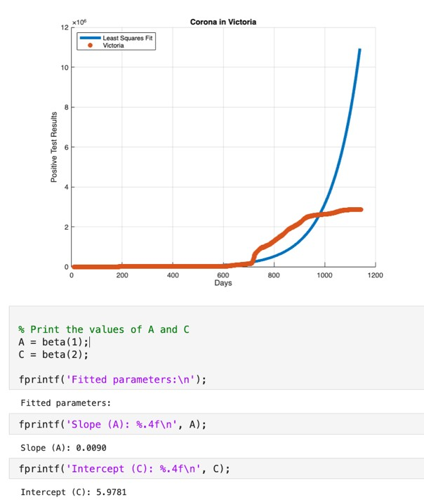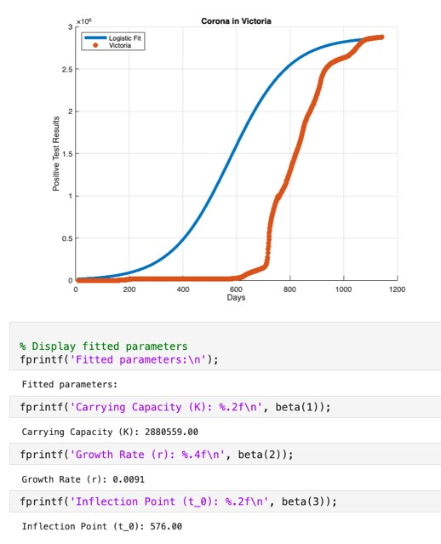

|  |  |  |  |
| --- | --- | --- | --- |
| |  | | --- | | ***Figure 4. Exponential fit using least squares for confirmed cases of COVID*** ***-19 in Victoria for days 500-800 and 1-250 with parameters*** | | |  | | --- | | ***Figure 5. Logistic fit for confirmed cases of***  ***COVID-19 in Victoria for the first 600 days with parameters*** | |

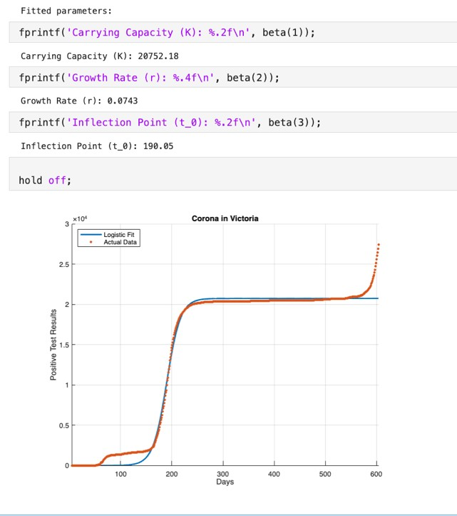 ***Figure 6. Exponential fit using least squares for***

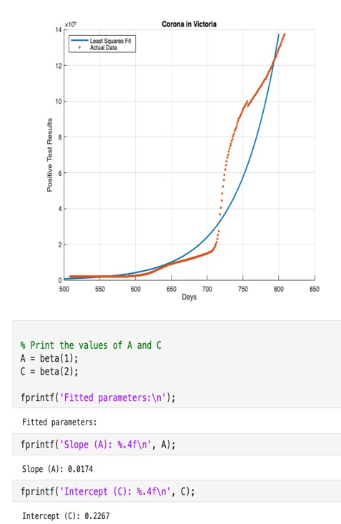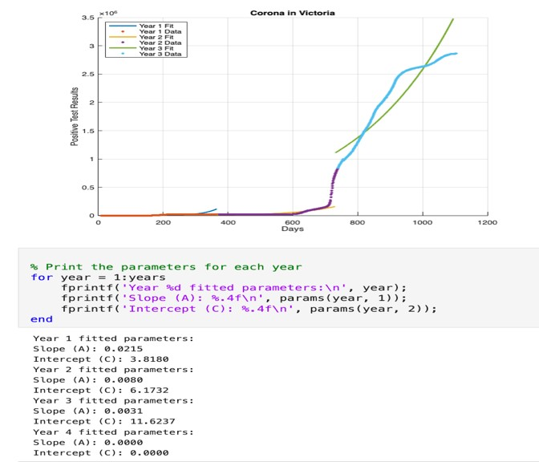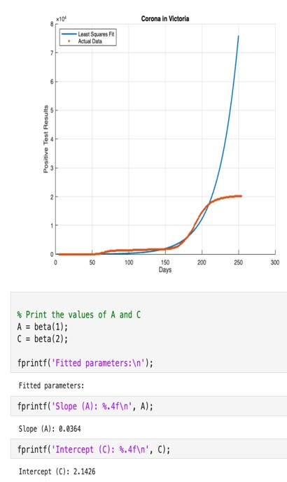

***confirmed cases of COVID-19 in Victoria sub set into years***

|  |  |  |
| --- | --- | --- |
| ***Figure 7. Exponential fit using least squares for confirmed cases of COVID-19 in South Australia***  ***with parameters*** |  | ***Figure 8. Logistic for confirmed cases of COVID-***  ***19 in South Australia with parameters*** |

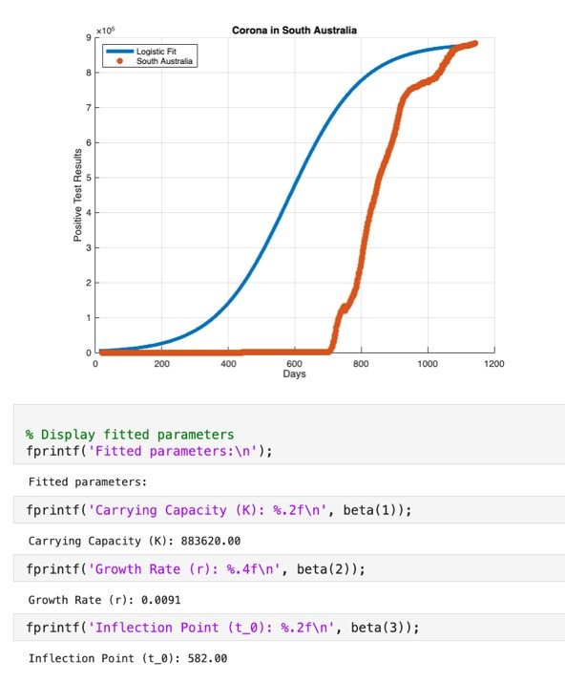

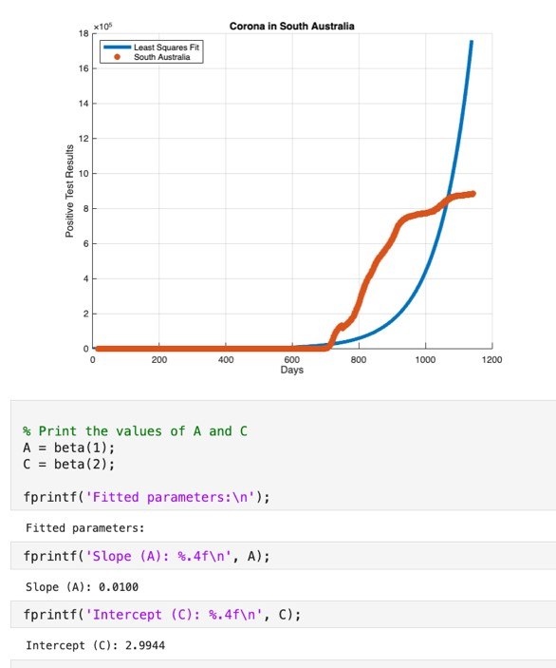

|  |  |  |
| --- | --- | --- |
| ***Figure 9. Exponential fit using least squares for confirmed cases of COVID*** ***-19 in South Australia with parameters days 600-800 and days 1-100*** |  | ***Figure 10. Logistic for confirmed cases of***  ***COVID-19 in South Australia with parameters days 1-400 and 700-1143 days*** |

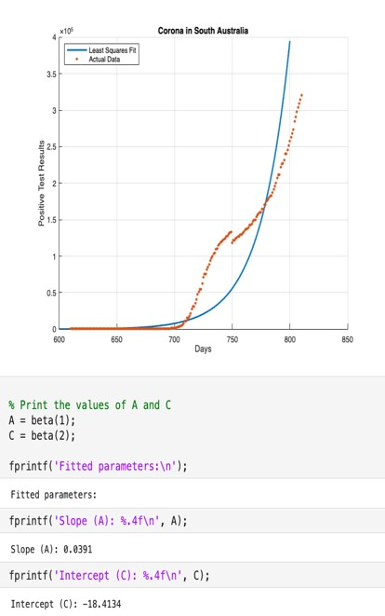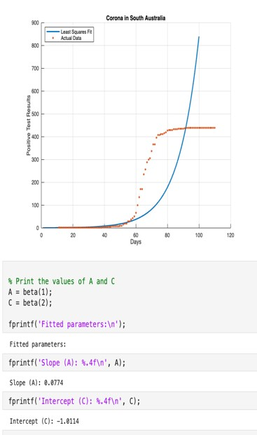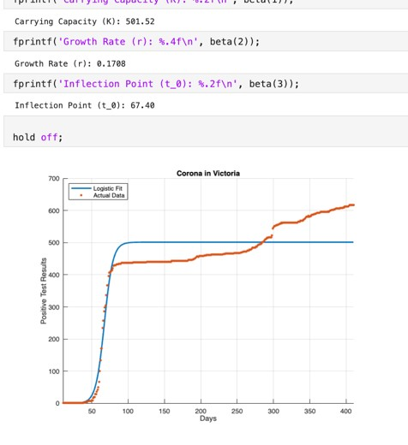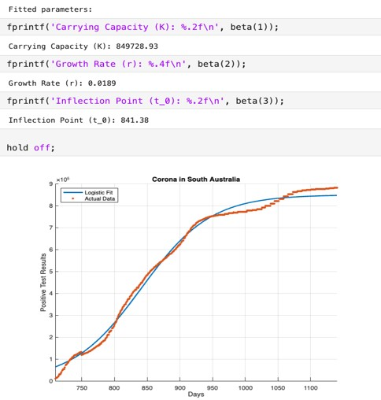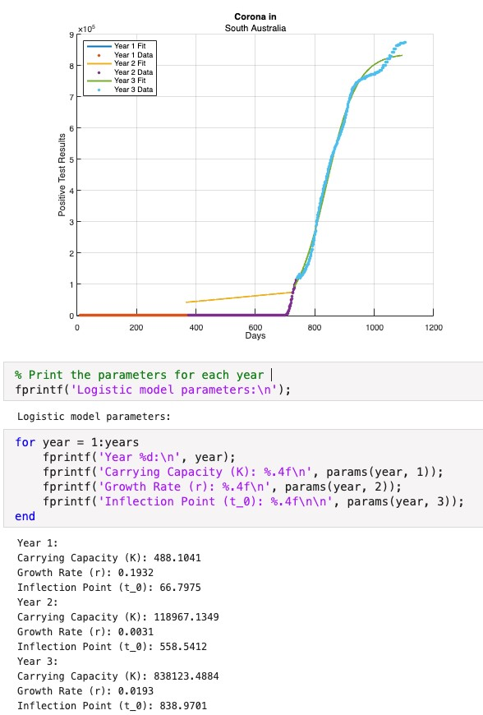

***Figure 1***

***1***

***.***

***Logistic fit***

***subset into years***

***of COVID***

***-***

***19***

***confirmed cases***

***in South***

***Australia***

# Results/Discussion

Figures 2, 3, 6 and 7 show fitting the entire dataset isn’t appropriate. Triambak (2021) recommends logistic growth models due to their better reflection of epidemic progression although it’s clear improvement is needed.

Figure 4 for Victoria shows days 1-250, we observe A = 0.0364 and C = 2.1426, while for South Australia in Figure 9, for days 1-100, A = 0.0774 and C = -1.0114. Macintyre (2021) highlighted that effective mitigation strategies could reduce cases by up to 90%. Following a lockdown around day 100, both states transitioned to a plateau phase.

In South Australia 1-400 days, the logistic model in Figure 10 growth rate was relatively high at 0.1788 despite other parameters indicating plateau. The actual data continued a positive trend and Stobart (2022) explains South Australia employed lenient restriction policies resulting in the later periods more accurately fitting the exponential model in figure 9 as predicted by Chang (2020).

The logistic model fitted to Victoria over 600 days, Figure 5, aligns with Chang’s (2020) findings, indicating that the logistic model's continuation is contingent on effective mitigation strategies. The fluctuation of restrictions led to multiple surges, specifically for days 500-800 with the exponential model fitting a slope (A) of 0.0174 and an intercept (C) of 0.2276. Although still being less catastrophic than South Australia due to constant preventive measures.

Subsetting the data into years allows for clear interpretations over the course of longer times. In Victoria, figure 6, Year 1 showed a steep increase, with a slope of 0.0226 and an intercept of 3.5991. Year 2 and 3 exhibited a slower increase and a higher baseline, suggesting diminishing spread rates, possibly due to constant preventive measures. In South Australia figure 11 more accurately represented by a logistic fit, initially, there was rapid growth, with a rate of 0.1932. In years 2 and 3 transmission potential increased significantly but at a slower rate eventually stabilizing after a prolonged exponential growth phase at 838.9701 days.

# Future Work

Future work can refine trend prediction models by combining exponential, logistic, and other growth models. Comparative analysis with other regions can highlight best practices, while temporal analysis can reveal variant impacts. Integrating behavioural and socioeconomic factors can improve compliance and demographic understanding.

# Conclusion

This study analysed COVID-19 trends in Victoria and South Australia using exponential and logistic growth models. Logistic models accurately depicted the epidemic's progression stages. Effective mitigation slowed initial spread in Victoria, while South Australia showed distinct phases influenced by public health responses. Yearly analysis emphasized adaptive strategies' significance.

# References

1. Eshragh, A., Alizamir, S., Howley, P., & Stojanovski, E. (2020). Modeling the dynamics of the COVID-19 population in Australia: A probabilistic analysis. *Plos one*, *15*(10), e0240153.
2. Chang, S. L., Harding, N., Zachreson, C., Cliff, O. M., & Prokopenko, M. (2020). Modelling transmission and control of the COVID-19 pandemic in Australia. *Nature communications*, *11*(1), 5710.
3. Cook, M. J., Dri, G. G., Logan, P., Tan, J. B., & Flahault, A. (2020). COVID-19 down under: Australia’s initial pandemic experience. *International journal of environmental research and public health*, *17*(23), 8939.
4. Triambak, S., Mahapatra, D. P., Mallick, N., & Sahoo, R. (2021). A new logistic growth model applied to COVID-19 fatality data. *Epidemics*, *37*, 100515.
5. Gomez-Cravioto, D. A., Diaz-Ramos, R. E., Cantu-Ortiz, F. J., & Ceballos, H. G. (2021). Data analysis and forecasting of the COVID-19 spread: A comparison of recurrent neural networks and time series models. *Cognitive Computation*, 1-12.
6. <https://data.humdata.org/dataset/novel-coronavirus-2019-ncov-cases>
7. Stobart, A., & Duckett, S. (2022). Australia's response to COVID-19. *Health Economics, Policy and Law*, *17*(1), 95-106.
8. MacIntyre, C. R., Nguyen, P. Y., Chughtai, A. A., Trent, M., Gerber, B., Steinhofel, K., & Seale, H. (2021). Mask use, risk-mitigation behaviours and pandemic fatigue during the COVID-19 pandemic in five cities in Australia, the UK and USA: A crosssectional survey. *International Journal of Infectious Diseases*, *106*, 199-207.

# Appendix

